Differential pair
In PCB design, a differential pair refers to two parallel signal traces that carry equal but opposite voltage signals. This technique is commonly used in high-speed digital and analog circuits to ensure accurate signal transmission and reduce noise interference. By transmitting complementary signals and measuring the voltage difference between them, differential pairs effectively cancel out common-mode noise, resulting in better signal integrity and electromagnetic compatibility.
Differential pairs are used in high-speed and noise-sensitive communication interfaces, where signal quality and timing are critical.
Common Applications:
- USB (D+, D–)
- Ethernet (TX±, RX±)
- HDMI (TMDS pairs)
- PCI Express (TX±, RX±)
- LVDS / Display Interfaces
- SATA / MIPI / CAN / RS-485 communication lines
We use differential pairs to:
- Reduce Noise:
Any external noise that couples into both lines is canceled at the receiver.
- Minimize EMI:
Equal and opposite currents produce magnetic fields that cancel out.
- Improve Signal Integrity:
The receiver measures the voltage difference (D+ – D–), not the voltage to ground.
- Avoid Ground Dependency:
Works well even with ground noise or potential differences.
- Support High-Speed Communication:
Maintains accurate data transfer at MHz–GHz frequencies.
USB as a Differential Pair
USB Pin Configuration
Pin | Name | Function
1 | VBUS | +5 V power supply
2 | D– | Differential Data –
3 | D+ | Differential Data +
4 | GND | Ground

USB uses D+ and D– as a differential pair to transmit and receive digital data between the host (e.g., PC) and device (e.g., keyboard, pendrive, etc.).
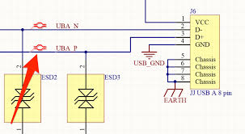
USB Differential Pair Concept
- D+ carries the positive version of the data signal.
- D– carries the inverted (negative) version of the same signal.
- The receiver doesn’t read the voltage of one line to ground — it measures the difference:
$$V_{diff}=D+-D-$$
- This allows noise cancellation and error-free communication even at high speed.
How Data Transmits Between Devices
Let’s take a simple example to visualize data flow:
Suppose the USB host wants to send this data bit sequence:
Data = 1010
The USB driver converts these bits into differential voltage levels:
Bit | D+ | D– | Vdiff = D+ – D– | Logic at Receiver
1 | High | Low | + | Logic ‘1’
0 | Low | High | – | Logic ‘0’
So, for data 1010, the D+ and D– lines behave as:
Bit | D+ (V) | D– (V) | Vdiff = D+ – D– | Receiver Logic
1 | +3.3 V | 0 V | +3.3 V | Logic ‘1’
0 | 0 V | +3.3 V | –3.3 V | Logic ‘0’
1 | +3.3 V | 0 V | +3.3 V | Logic ‘1’
0 | 0 V | +3.3 V | –3.3 V | Logic ‘0’
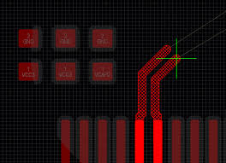
Differential Pair Layout
The receiver looks at the difference between D+ and D– and reconstructs the original bit stream (1010).
Differential Impedance Control
Differential impedance is the total impedance between two signal traces that form a differential pair. Maintaining proper differential impedance is crucial for high-speed signal integrity and reliable data transmission.
- Definition:
It is the impedance measured between the D+ and D– (or RX+ and RX–) lines of a differential pair while both signals switch in opposite phases.
- Typical Values:
  - USB 2.0 → 90 Ω ±10%
  - HDMI, Ethernet, PCIe → 100 Ω ±10%
- Why It’s Important:
Incorrect impedance causes signal reflection, attenuation, and timing errors, which can distort data and increase EMI.
- Factors Affecting Differential Impedance:
  - Trace width (W)
  - Trace spacing (S)
  - Dielectric height (H) between signal layer and ground plane
  - PCB dielectric constant (εr)
- Design Tips:
  - Use PCB impedance calculators (like Saturn PCB or Altium’s built-in tools).
  - Maintain consistent width and spacing across the entire trace.
  - Avoid vias and sharp bends that disturb impedance.
  - Keep the reference ground plane continuous under the differential pair.
Trace Width and Spacing
Differential pair routing requires precise trace width (W) and spacing (S) to maintain the correct differential impedance (Zdiff).
This impedance ensures signal integrity and minimizes reflections in high-speed data lines like USB, HDMI, and Ethernet.
Formula for Differential Impedance
A simplified approximation (for microstrip) is:
$$Z_{diff}≈2Z_{0}[1-0.48e^{-\frac{0.96S}{H}}]$$
Where:
- $Z_{0}$= Single-ended impedance (Ω)
- $S$= Spacing between traces (mm or mils)
- $H$= Dielectric height between signal layer and reference plane (mm)
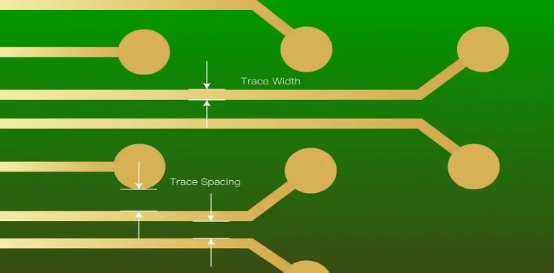
Typical design target:
$$Z_{diff}=90Ω\text{–}100Ω$$
- Keep constant width (W) and spacing (S) along the entire differential pair.
- Avoid sharp corners; use smooth 45° bends or arcs.
- Never separate the traces — route both side-by-side on the same layer.
- Avoid vias in differential pairs — vias add inductance and delay mismatch.
- Use impedance calculators or field solvers to validate Zdiff before routing.
Length Matching Techniques
Length matching ensures both differential traces deliver signals simultaneously, preventing timing skew and phase distortion.
Methods of Length Matching
- Serpentine (Meander) Routing
  - Add short zigzag (meander) patterns to the shorter trace to equalize lengths.
- Symmetrical Path Routing
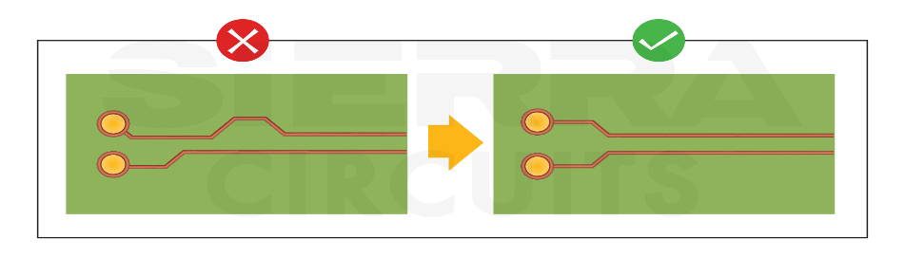
  - Maintain the same number of bends and identical geometry in both traces.
- Avoid Unequal Vias
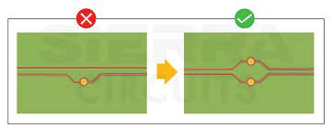
  - Use the same number of vias on both traces or avoid vias entirely.
- Post-Layout Tuning
  - Fine-tune critical high-speed pairs using length tuning tools in the PCB editor.
Tolerance Examples
Interface | Typical Zdiff | Max Skew
USB 2.0 | 90 Ω | ≤ 150 mils (3.8 mm)
PCIe | 85 Ω | ≤ 5 mils (0.13 mm)
HDMI | 100 Ω | ≤ 10 mils (0.25 mm)
Return Path Integrity
- Ensure a continuous ground reference plane beneath the differential pair.
- Avoid plane splits or breaks under the traces to prevent impedance discontinuities and unwanted noise.
Length Matching and Skew
- Differential signals must arrive at the receiver simultaneously to avoid data errors.
- If one trace is shorter, use meanders or serpentine patterns to match lengths.
Crosstalk and Noise Reduction
- Keep proper spacing from other high-speed signals to reduce interference.
- Consider shielding and careful layer stack-up to minimize crosstalk and EMI.
Connector and Termination Design
- Assign pins carefully (e.g., USB D+ and D–) to maintain signal integrity.
- Include differential termination resistors where needed to match the impedance of the line.
- Common Design Mistakes
  - Unequal trace lengths causing skew
  - Crossing plane gaps under differential traces
  - Incorrect spacing or sharp bends leading to reflections
- Design Example
  - Example: USB 2.0 differential pair routing
  - Explanation of data flow through D+ and D– and proper layout techniques to maintain signal quality.

